VSTS Continuous integration selenium Configuration

Azure VM Configuration Details
- IP address : 52.151.73.46
- UserName : TestVM
- Password : Password@123
Ref URL : http://donovanbrown.com/post/2015-ignite-new-zealand-demo-prep-step-2

Agent configuration Details in VM
Remote Machine: C:\Agent1
Steps To create a new agent in VM

Download Agent from VSO
- Open Internet Explorer
- Navigate to your VSO account
- Click the Administer Account gear in the upper right hand corner of the screen
- Select Control panel
- Click Agent pools tab
- Click the Download agent link
- Save the file to your Downloads folder
- Right-click agent.zip
- Select Properties
- Ensure the file is unblocked

Extract the file to Agent1 folder
- Right-click agent.zip
- Select Extract All
- Enter C:\Agent1
- Click Extract

Run ConfigureAgent.cmd in elevated command prompt
- Press the Windows key
- Type CMD
- Right-click Command Prompt
- Select Run as administrator
- Navigate to the folder where you extracted the file contents
- Run ConfigureAgent.cmd
- You can either use the default name or have the name match the folder name, which in my case is Agent1
- Now enter your Visual Studio Online URL
- Enter the agent pool to which you would like to add this agent.
- Every Visual Studio Online account is created with two Agent Pools: Default and Hosted. You are free, however, to create additional agent pools from the page where you downloaded the agent.
- Accept the default working folder
- You have a choice to decide where you would like the agent to store the files it will be working with during builds and releases.
- Answer N
- Because we are going to be running Selenium tests we will want to run the agent in interactive mode.
- Sign in to your Visual Studio Online account

Set up Agent in Interactive Mode
- Enable automatic log in
- Open the Run dialog
- Press Windows Key + R
- Type “control userpasswords2”
- Press enter
- Uncheck the box for “User must enter a user name and password to use this computer.”
- Click the Apply button
- Enter the password for the user
- Click OK
- Click OK on the Users Accounts dialog
Now, every time your machine is rebooted the configured user will automatically log in to the machine.

Verify Agent is running in VM
Open command prompt in adminstrator mode Enter command c:\Agent1>run --startuptype autostartup
Ref: http://chamindac.blogspot.co.uk/2017/12/running-ui-tests-with-unified-agent.html
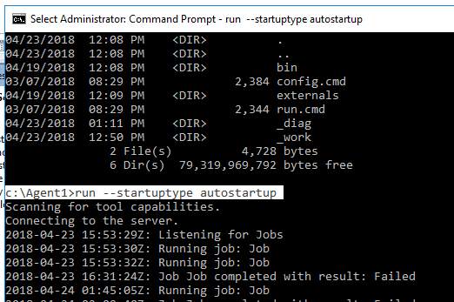

VSTS Agent Pool Details

- Agents for pool Selenium AzureVM - Selenium Azure VM
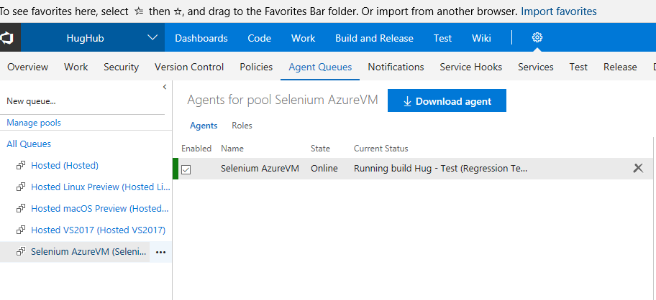

PAT Token Used to create this agent- uq4sye7ucq76vfznbe6jwoheslij72qz3ngqafxls444i3dl4iaq

Create a New Build Definition

- Select Agent queue as Selenium Azure VM

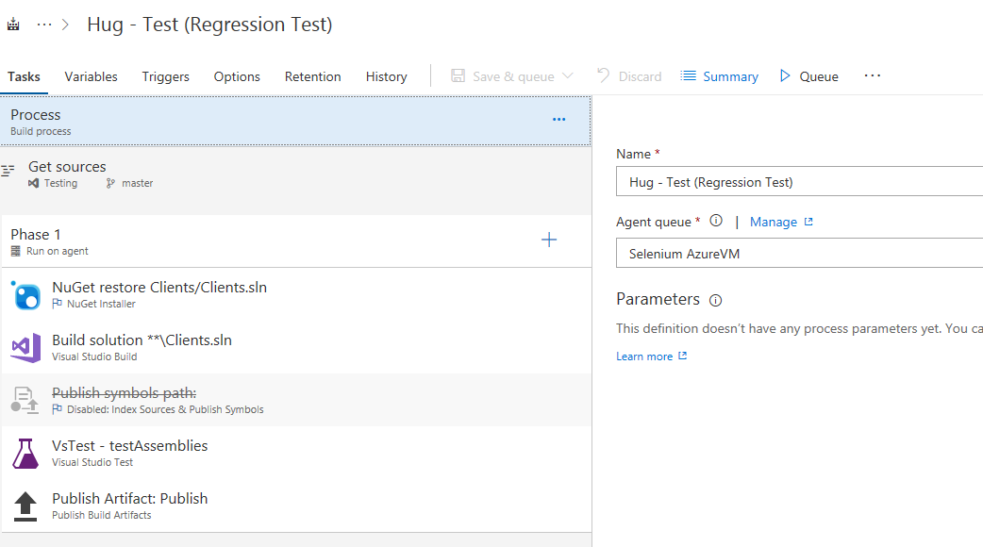

Build Solution
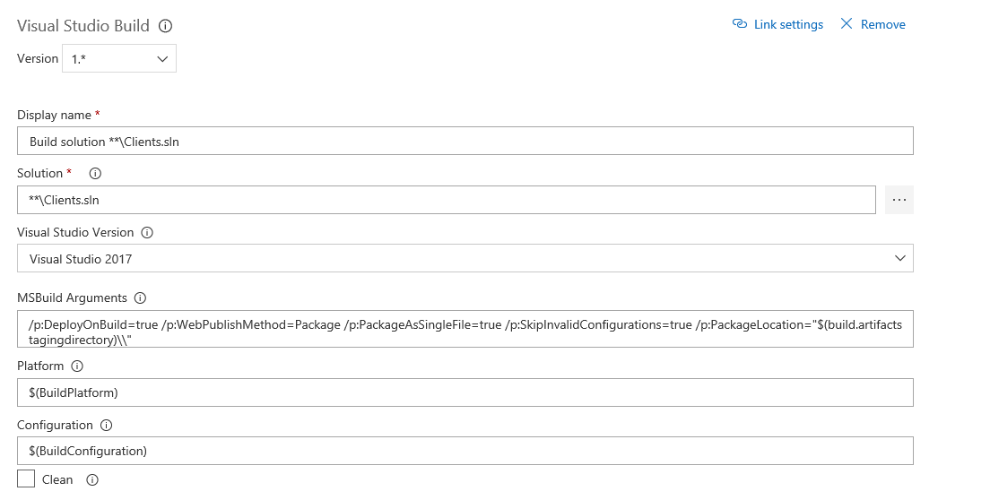

- Configure VS Test Assemblies
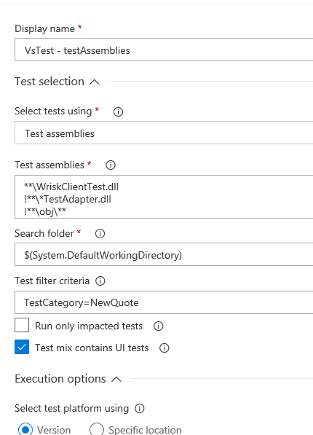

Publish Build Artifacts
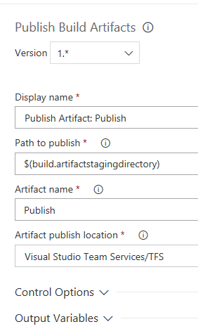

Trigger Regression Build Every night
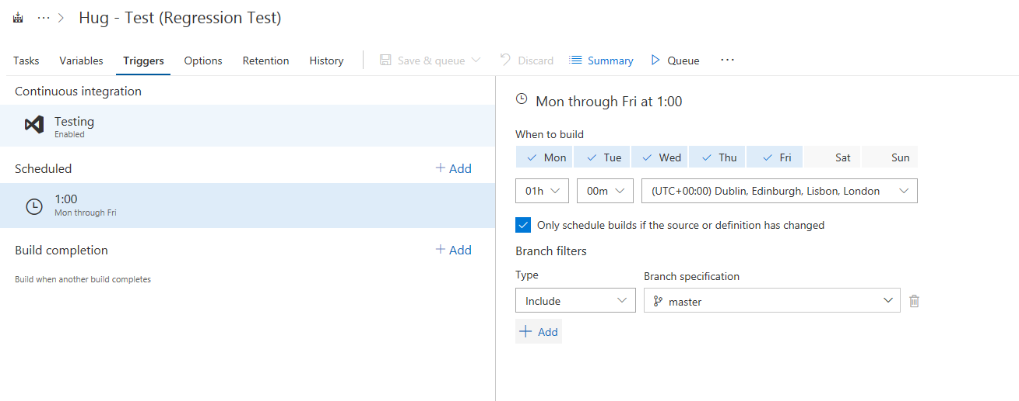

Trigger Continuous Integration

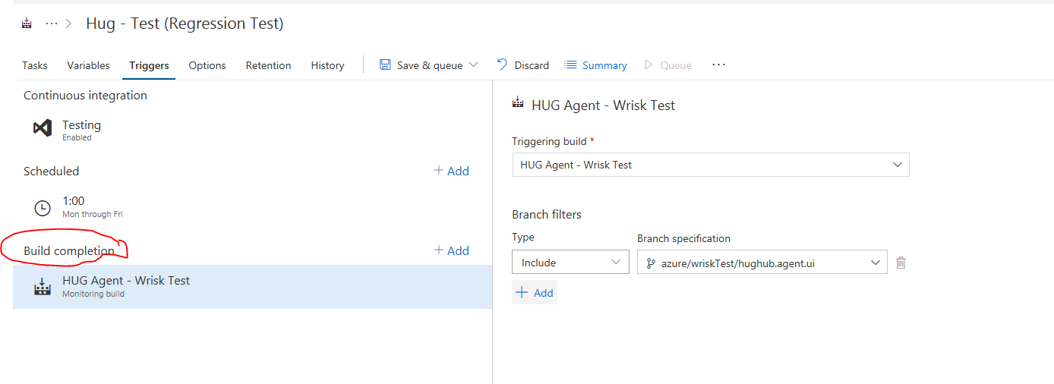

Test Results
We can see Test reults in tests section and we can filter it
